**PERSONAL DAIRY**

**Internship Project Report,**

Based on Web and MEAN Stack.

**Objective** :- Add a new note, Update existing note and Store them.

Conducted By :-

“Abhiyantrix And Sapience Academy Mysuru”

Under Supervision Of :

Mr. Krishna

Submitted By :

**Likitha B V (1CC15CS011)**

**Poornima K (1CC15CS018)**

**Ranjitha R (1CC15CS019)**

**Sashank Rai (1CC15CS021)**

**Suhas B S (1CC15CS023)**

**Satish Gowda P A (1CC15IS001)**

**Sujatha V (1CC14CS018)**

**Acknowledgement**

We are pleased to acknowledge Mr. Krishna for his guidance during the course

and commencing the project work.

We extend our sincere thanks to Miss. Anjana Shashi Kiran and Mr.

Harshith who conducted this Internship program and helped us throughout the

program.

We are also be thankful for all the members and team of “Abhiyantrix And

Sapience Academy Mysuru”.

**Contents**

1. Acknowledgement

2. Contents

3. Introduction

4. Project Description

5. Source Code

6. Snapshots

7. References

**Introduction**

**Overview**

The dairy, as the name indicates, this app is used to store information. This

helps user to Login or Sign-Up to the app and add a new description

This project has been conducted using HTML and CSS. Hypertext Markup

Language (HTML) which is a leading language that is being used in Web

Development. Cascading Style Sheet (CSS) is a style sheet used to apply styles

and formatting the page which makes the Web Page looks attractive and

effective. MEAN Stack is used for backend connection and creating a database

to store the user details and user notes.

Project Description

The project’s frontend has been edited using Notepad++ text editor. MEAN

(MongoDB, Express, Angular and Nodes) is used to connect the frontend with

the backend. MongoDB is used for the database, to store user name, email,

password, and notes that user added to the account. The project uses several

steps, which is as follows:

1. The user can see the information of particular day by giving date and text.

Source Code

**<html>**

**<head>**

**<title>Login</title>**

**<link rel="stylesheet" href="login.css">**

**<script src="http://code.jquery.com/jquery-1.11.1.min.js"></script>**

**<script src = "login.js" type="text/javascript"></script>**

**</head>**

**<body>**

**<div class="login-box">**

**<form>**

**<h1>Login</h1>z**

**<div class="textbox">**

**<i class="fa fa-envelope" aria-hidden="true"></i>**

**<input type="text" placeholder="Email Id" name="" value="">**

**</div>**

**<div class="textbox">**

**<i class="fa fa-lock" aria-hidden="true"></i>**

**<input type="password" placeholder="Password" name="" value="">**

**</div>**

**<a href="notes.html">**

**<input class="btn" type="button" name="" value="Sign In">**

**</a><br><br>**

**Create an Account?<a href="signup.html">Click Here!</a>**

**</form>**

**</div>**

**</body>**

**</html>**

**Code for Sign-Up page:**

**<html>**

**<head>**

**<title>Sign Up</title>**

**<link rel="stylesheet" href="login.css">**

**<script src="http://code.jquery.com/jquery-1.11.1.min.js"></script>**

**<script src = "login.js" type="text/javascript"></script>**

**</head>**

**<body>**

**<div class="login-box">**

**<form>**

**<h1>Sign Up</h1>**

**<div class="textbox">**

**<i class="fa fa-user" aria-hidden="true"></i>**

**<input type="text" placeholder="First Name" name="" value="">**

**</div>**

**<div class="textbox">**

**<i class="fa fa-user" aria-hidden="true"></i>**

**<input type="text" placeholder="Last Name" name="" value="">**

**</div>**

**<div class="textbox">**

**<i class="fa fa-envelope" aria-hidden="true"></i>**

**<input type="text" placeholder="Email id" name="" value="">**

**</div>**

**<div class="textbox">**

**<i class="fa fa-phone" aria-hidden="true"></i>**

**<input type="text" placeholder="Phone Number" name="" value="">**

**</div>**

**<div class="textbox">**

**<i class="fa fa-lock" aria-hidden="true"></i>**

**<input type="password" placeholder="Password" name="" value="">**

**</div>**

**<a href="dairy.html">**

**<input class="btn" type="button" name="" value="Sign Up">**

**</a>**

**</form>**

**</div>**

**</body>**

**</html>**

**Code for server connection:**

**const express = require('express');**

**const morgan = require('morgan');**

**const mongoose = require('mongoose');**

**const bodyParser = require('body-parser');**

**const routes = require('./routes/routes');**

**mongoose.Promise = global.Promise;**

**const app = express();**

**mongoose.connect('mongodb://localhost:27017/user',{ useNewUrlParser: true });**

**app.use(bodyParser.urlencoded({ extended: true }));**

**app.use(morgan('dev'));**

**routes(app);**

**app.use((err,req,res,next) => {**

**res.status(422).send({ status: false, error: err.message });**

**});**

**const ip = '127.0.0.1';**

**app.listen(3000,ip, () => {**

**console.log('Server listening at '+ip+':3000');**

**});**

**Code for Login and Sign-Up:**

**const user = require('../controller/user');**

**const path = require('path');**

**module.exports = (app) => {**

**app.get('/', (req,res) => {**

**res.sendFile(path.join(__dirname+'/../login.html'));**

**});**

**app.post('/login',user.login);**

**app.get('/signup', (req,res) => {**

**res.sendFile(path.join(__dirname+'/../signup.html'));**

**});**

**app.post('/signup',user.signup);**

**}**

**SNAPSHOTS**

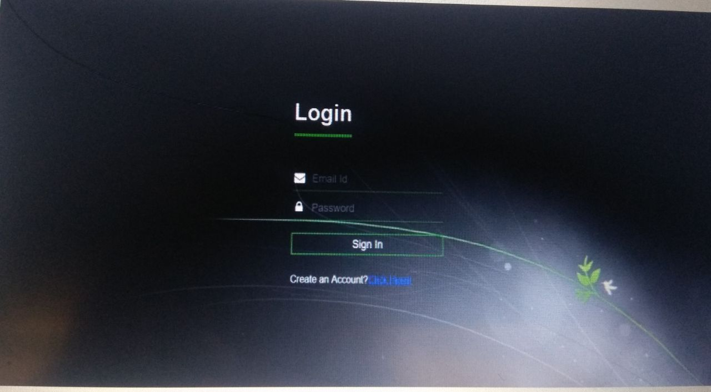

**This snapshot shows the page that a user can login to the app**

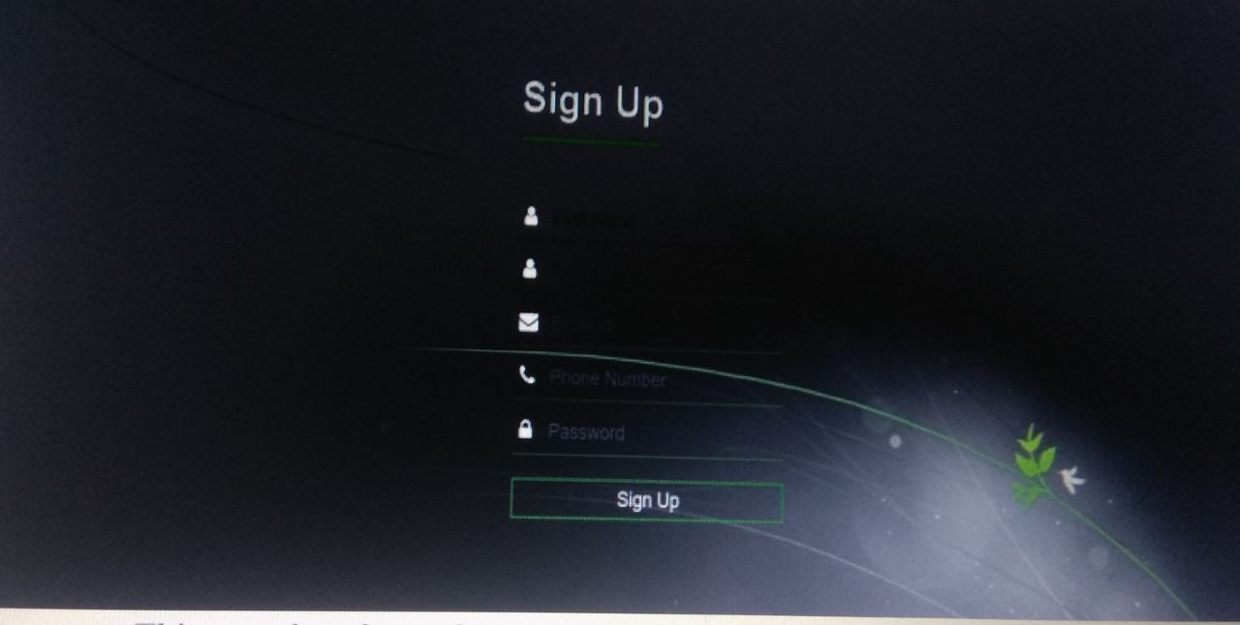

**This snapshot shows the page that a user can signup for the app**

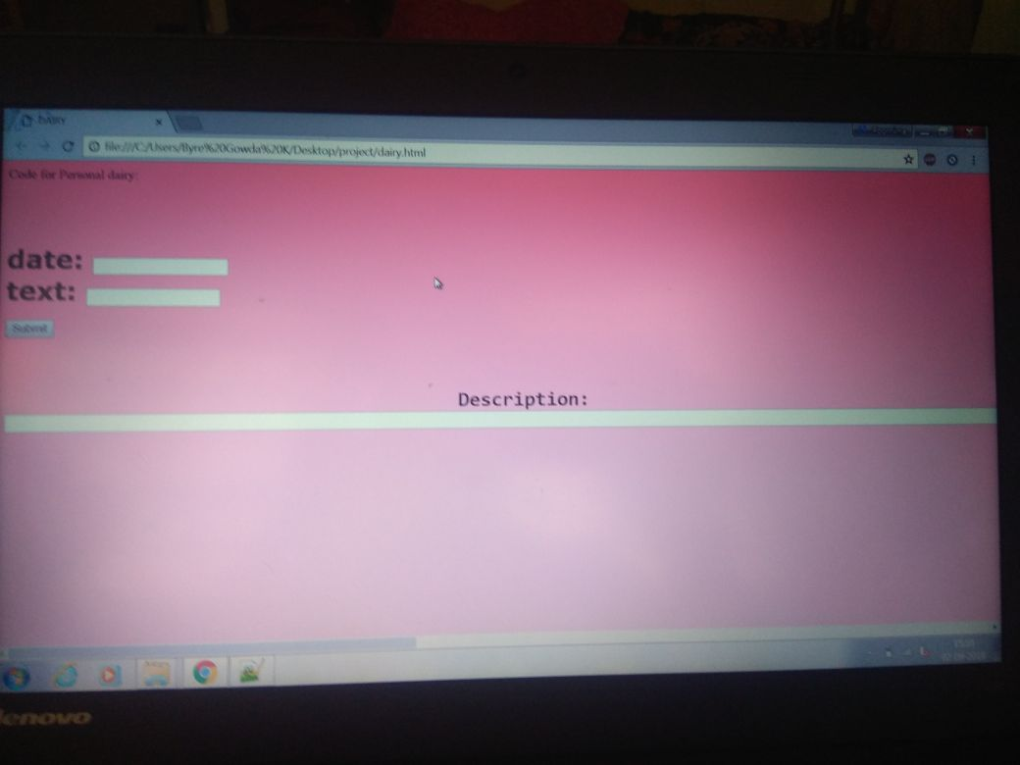

**This page displays the description by giving the text and date**

**References**

**1. YouTube videos on MEAN stack.**

**2. HTML & CSS The Complete Reference, Fifth edition, Thomas A. Powell**